**Project description**

**Emergency call system**

Date: **03/02-11**

Advisor: Kim Bjerge

Project participants: Jørgen Vrou Hansen (20042728)

Saiid Shah Alizadeh (19963592)

Anders Hvidgaard Poder (19951439)

Revision: **A**

Document ID: **PRODDESC**

# Scope and Objective

The primary objective for this project is to analyze an architecture from a specification and map this architectural solution to a selected platform. The architectural solution will contain a simulation of the most important modules. Design space exploration, partitioned technique and profiling *[Gajski]* will be used in order to archive the best trade-off between cost, performance and dependability. Some of these quality constraints riposte each other, and therefore it is essential that the architecture reflects the quality attribute which is most important for the defined product.

Stakeholders always want a dependable system, which perform the best and cost the least. Ours objective will be to find the best platform that fulfills the stakeholders requirements. Therefore different platform architecture will be considered including MIPS and FPGA, and each platform will be analyzed to archive the best trade-off between system quality attributes defined by the stakeholders.

As this project has a limited time schedule, the architectural design and implementation will focus on modeling at the (Timed) TLM level in SystemC. These simulations will also be used as proof of concept, and the further syntheses from behavior to structure as defined by *[Gajski]*. As mentioned above the project has limited time schedule, and therefore only the most important steps in the syntheses will be described.

From a learning perspective, group members have indicated that a major learning area is going from higher level UML/SysML abstraction, where the overall system architecture is defined, to a specific platform. The whole syntheses from higher level abstraction to implementation and the steps needed is one of the interesting focus areas for the project, as well as risk level management *[INCOSE]* at higher abstraction.

# Terms and definitions

|  |  |  |
| --- | --- | --- |
| **Term/Phrase** | **Definition** | **Short form** |
| Emergency call | The result of activating the emergency call button and will place the care recipient in verbal communication with a care giver while another care giver is dispatched to the location of the care recipient. |  |
| Emergency call System | The overall system as a whole including the Emergency call base, Emergency call button and Emergency call server. In Danish “Nødkald” | System |
| Emergency call button | The device that is the final result of this project. It is a “small” battery-powered device that is worn around the neck or wrist and when activated sends a signal to the Emergency call base. In Danish “Panikknap”. It also allows two-way communication with the care giver head office. | Button |
| Emergency call base | An existing device which forwards the signal from the emergency call button to the emergency call server. The emergency call base is powered by a 230V continuous supply. | Base |
| Emergency call server | A server located at the care giver head office and receives information from all emergency call bases in the city and forwards any emergencies to the interested parties (care giver, technician, …). | Server |
| Caregiver | The person giving care to an elderly or disabled person (care recipient). It may both be the person at the head office receiving an emergency call, or the person being dispatched to give care in person. In Danish either a “Hjemmeplejer” or “Sygeplejerske”. |  |
| Care recipient | An elderly or disabled person who may be issued an Emergency call base and one or more buttons. | User |
| Technician | A person with a basic technical knowledge of the emergency call system to the level where he can do basic maintenance (replace batteries and install new bases and buttons). Also the receiver of errors and warnings from the emergency call system. |  |
| Care giver head office | The location of the emergency call server, the care giver on call and the technicians. | Head office |

# Specification

Please refer to the original project proposal [PORJPROP] and the Requirements specification [REQSPEC]

# Methodology and tools

1. Subversion (Google code), Microsoft Word 2007, Visio 2003 (also for time schedule)
2. SysML/UML,
3. SystemC for simulation.
4. INCOSE vs. Y-chart (top down).

The Technical aspect of any system can be described by *[INCOSE]*’s technical process as shown in the following figure.

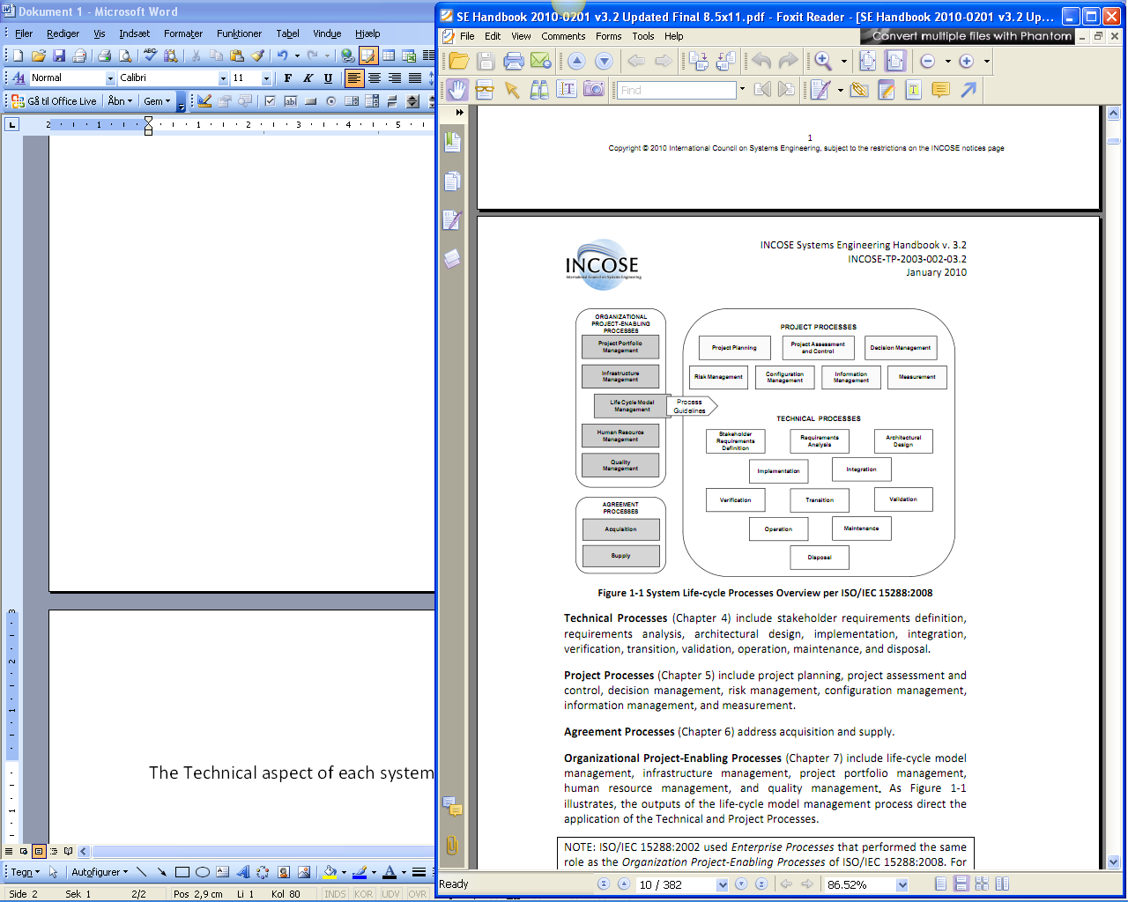

We follow the INCOSE guidelines through this project and wherever necessary, use other appropriate methods and approaches such as Y-chart, SysML and SystemC to support, model and evaluate the process.

The technical process begins with Stakeholder Requirements Definition followed by Requirement analyses. These will form the inputs for the Architectural design. At this point a system level synthesis described by *[Gajski]* will be utilized to support implementation.

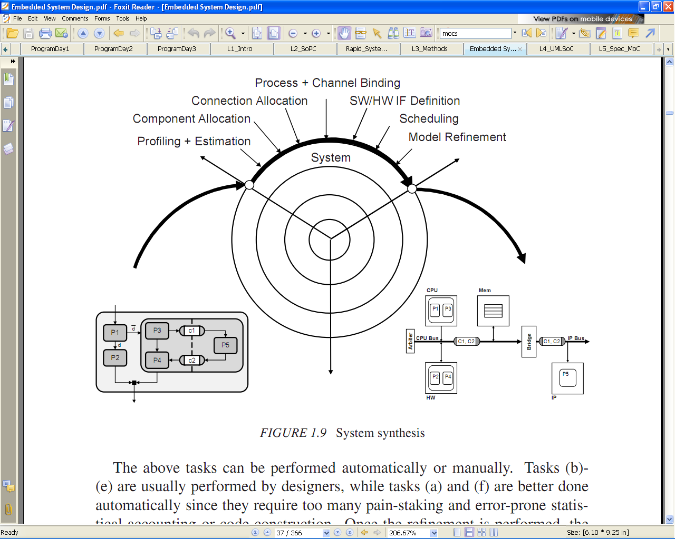

SystemC will be applied to verify the architectural design and generate an executable requirement. This will help us to simulate different designs and compare their metrics to choose the best fit.

The figure bellow is an visualization of the described process above.



# Working group contract

* We meet every Monday at 15:00.
* We hold Skype meetings as needed.

# Planning



# Refrences

|  |  |
| --- | --- |
| *[INCOSE]* | INCOSE System Engineering Handbook v.3.2 |
| *[Gajski]* | Embedded System Design, Modeling, Sunthesis and Verification by Daniel D. Gajski |
| *[PROJPROP]* | Original Project proposal on which this report is based. |
| *[REQSPEC]* | Requirement specification created from a requirement analysis of the project proposal. |